**Notes Map**

**You can’t use any framework. Your solution should just use vanilla javascript, CSS and**

**HTML.**

**Basic features [Target - 1]**

● A user should be able to create notes, where each note is made up of some text.

● One should be able to create a sub-note to a parent note by clicking on “New note”

button.

● There can be multiple top level Notes which are created by entering text in the top input

box and clicking “Submit” button.

● Ability to search. On search, it should show only the notes matching the search string.

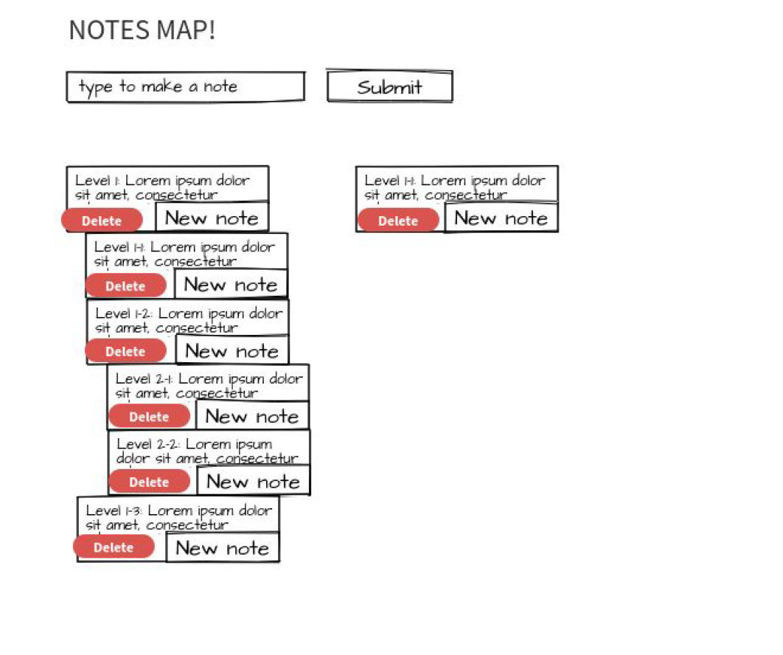

**Additional features [Target - 2]**

● Ability to edit the text of the notes

● Searching

○ It should highlight the matching text in each Note

○ It should show the lineage of the matching note, for e.g. if a leaf note is matched

it should show all its parent notes as well.

● Persist the notes in local storage so that refreshing the page also comes up with existing

notes

● Ability to delete, notes.

**Instructions**

Write proper modular, extensible code.

● Keep the UI neat and classy

● You’ll have 2 hours to finish the task.

● Feel free to search the internet for things you are not sure about

● You can’t use any framework. Your solution should just use vanilla javascript, CSS and

HTML.

● Time is short. Please manage your time well

● Ensure your code is modular and easy to understand

● Please include a note.txt file with your code where you should mention:

○ things you were able to complete

○ things you were unable to complete

○ things you would have taken care of if you had more time (briefly mention how

you would integrate that to your code)

○ if your code handles SEO, accessibility, responsive design, performance, etc,

mention that

○ And anything that you’d want to highlight during the evaluation of your code

● At the end, email your code along with screenshot(s) of what you have built to

rahul.arora@telekom-digital.com. Mention your full name in the email. You might need to

rename .js files to .txt if your email client blocks it)

● Please include screenshots that show:

○ feature multiple top level notes

○ multiple levels of sub-notes

○ search notes

● Aim to have a usable product at the end with working features. Do not implement

multiple features half way, but none completely working.